<html>

<title> PRACTICAL 1 </title>

<body>

<ul>

<h1> list of sections </h1>

<li> SEC A </li>

<li> SEC B </li>

<li> SEC C </li>

<li> SEC D </li>

<li> SEC E </li>

<li> SEC F </li>

<li> SEC G </li>

</ul>

<ol>

<li> SEC A </li>

<li> SEC B </li>

<li> SEC C </li>

<li> SEC D </li>

<li> SEC E </li>

<li> SEC F </li>

<li> SEC G </li>

</ol>

</body>

</html>

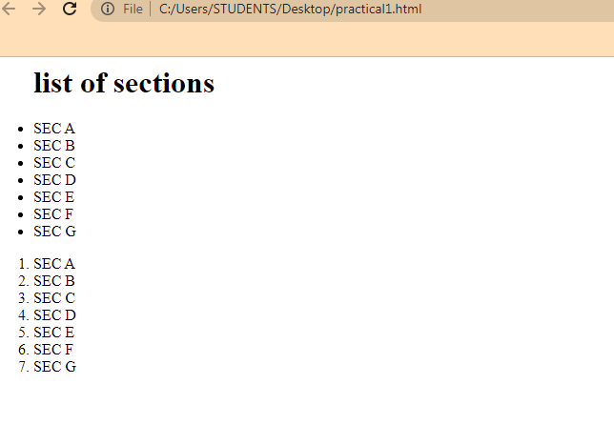<html>

<title> PRACTICAL 1 </title>

<body>

<body background ="C:\Users\Public\Pictures\Sample Pictures\Lighthouse.jpg">

<h3 style="color:red"> style tag </h3>

<dl>

<dt> SEC A </dt>

<dd> style = "color: red"> Room No. f-102 </dd>

<dt> SEC B </dt>

<dd> style = "color: red"> Room No. f-103 </dd>

<dt> SEC C </dt>

<dd> style = "color: red"> Room NO. 104 </dd>

</dl>

</body>

</html>

